
Standard Operating Procedure (SOP)

Authors: Angela Joseph Fernando
Alliance Bioversity-CIAT
Version: 1.0
Revision Date: 2025-09-03

- Overview
This SOP outlines the procedures for the curation of food samples by creating FoodON id within the metadata curation, after foods have been imported into the PTFI Sample Management System. This step follows after the data quality check process is finished.

The document provides detailed guidance on the following topics:
- Why FoodON IRIs Are Important
- How to access FoodON
- How FoodON is connected to other ontologies
- How to create Food on IRI for both specimen and sample

- Definitions
FoodON Ontology
A standardized vocabulary and ontology used for all food-related entities, including foods, ingredients, and processing types. It is to support consistent classification and metadata annotation of food products.
Ontology Lookup Service (OLS)
A web-based tool and repository for browsing and retrieving standardized ontology terms and their IRIs, used in metadata curation to assign consistent semantic identifiers from ontologies such as NCBI Taxonomy and FoodON.
CORE Metadata
The foundational metadata elements for each sample, including key descriptors such as Specimen Organism Name, Specimen Food Product Name, Specimen Preparation, and Specimen Preparation Method, used to guide accurate ontology term assignment.
What is FoodON IRI
A unique and unambiguous identification called as Internationalized Resource Identifier assigned for the food or the biological source of the sample or specimen that gives a universal code. This can be merged, compared, and reused globally.
Specimen Organism IRI
A standardized Internationalized Resource Identifier from the FoodON ontology assigned to the taxonomic classification of the organism from which the specimen originates. It ensures unambiguous reference to the biological source of the sample.
Specimen Food Product IRI
An Internationalized Resource Identifier derived from the FoodON ontology that categorizes the food product form of the specimen, considering the food name, preparation, and processing methods. It facilitates precise metadata annotation related to food types and states.
Sample Food Product IRI
Similar to the Specimen Food Product IRI, this identifier is assigned to the specific food product form of the physical sample itself, potentially differing from the specimen if they have different preparation or processing conditions recorded.
Curation status
It indicates the current stage and quality assessment of the sample metadata curation process. It guides users on whether a sample’s metadata have been properly reviewed, require correction, or are complete for downstream use.
ABS status
It is a regulatory status of a biological specimen, indicating whether its collection, use, and transfer comply with international agreements and national laws governing the ethical and legal use of genetic resources.
- Guidelines for contribution FoodON ID
3.1. Specimen Organism IRI
This is the first step in the curation process. This entity corresponds to the taxonomic classification of the specimen as defined in the NCBI Taxonomy ontology. This identifier can be retrieved through the Ontology Lookup Service (OLS) using the following procedure:
- Navigate to the NCBI Taxonomy ontology page in OLS:
https://www.ebi.ac.uk/ols4/ontologies/ncbitaxon
- Enter the Specimen Organism Name from the CORE metadata into the search bar (e.g., Allium cepa).
- From the search results, select the term that best matches the specimen organism.
- Copy the IRI (Internationalized Resource Identifier) associated with the selected term and record it in the metadata as the Specimen Organism IRI.
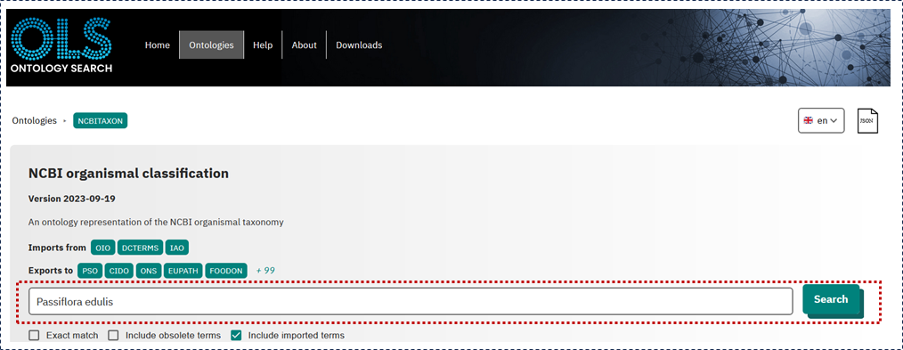
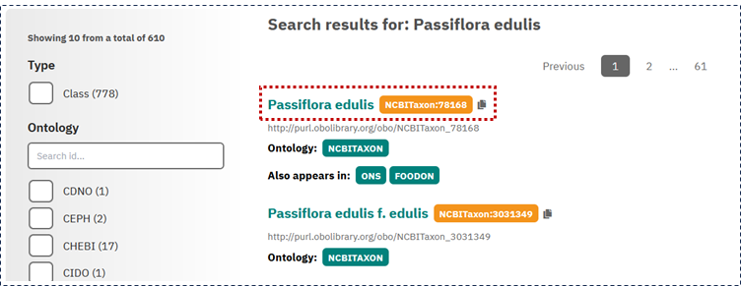

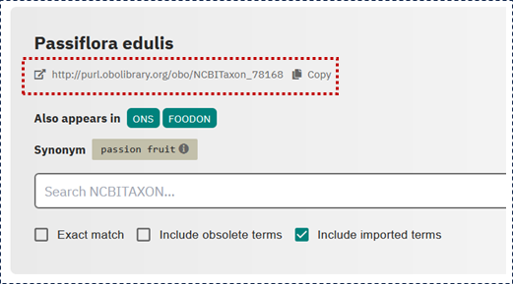

Specimen organism family
Follow the same to find the specimen organism family name
- Navigate to the NCBI Taxonomy ontology page in OLS:
https://www.ebi.ac.uk/ols4/ontologies/ncbitaxon
- Enter the Specimen Organism Name from the CORE metadata into the search bar (e.g., Passifloraceae).
- From the search results, select the term that best matches the specimen organism.
- Copy the IRI (Internationalized Resource Identifier) associated with the selected term and record it in the metadata as the Specimen Organism IRI.
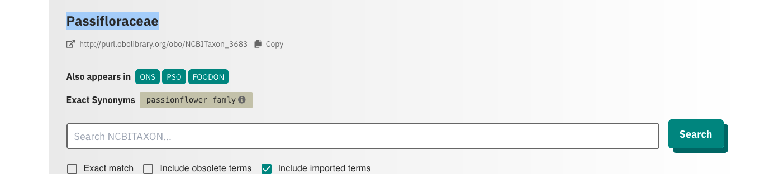



3.2. Specimen Food Product IRI
- Open the Ontology Lookup Service (OLS) for FoodON at:
https://www.ebi.ac.uk/ols4/ontologies/foodon
- Enter the Specimen Food Product Name (e.g., “passion fruit”) into the search bar.
- Review the list of returned terms carefully.
- From the search results, identify the term that best corresponds to the combination of the Specimen Food Product Name, Specimen Preparation, and Specimen Preparation Method (for example, “passion fruit (raw)” with FOODON ID: FOODON:03309552).
- Note that the FoodON classification system includes information about food processing in parentheses next to the food name. Avoid selecting terms containing the phrase “efsa foodex2” in the name (e.g., “31890 - juice, passion fruit (efsa foodex2)”).
- After selecting the appropriate food term, examine the panel at the bottom of the page displaying the FoodON hierarchy. Confirm that the chosen entity is derived from the “food material” category within the hierarchy.
- Be aware that a term might appear multiple times across the hierarchy due to various relationships with other terms. For example, “passion fruit (raw)” may be a subterm of both “passion food product” and “tropical fruit.” Despite these different contexts, the IRI remains the same.
- In the “Class Relations” panel, verify whether the Specimen Organism Name corresponds to the same taxon ID associated with this food product in FoodON. Some specific terms like “passion fruit (raw)” may not have a directly associated taxon. In such cases, by navigating up in the hierarchy, you may find the taxonomic classification linked to a broader term like “passion fruit.”
- If the selected food term lacks an associated taxon, it is important to submit a FoodON taxonomic issue as outlined in Section 3.3.
- Finally, copy the IRI associated with the selected food term for curation and annotation purposes.

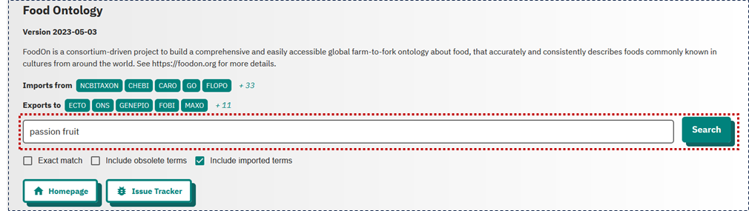
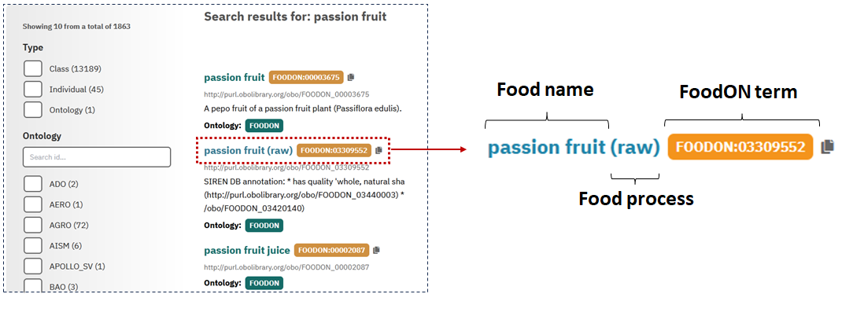
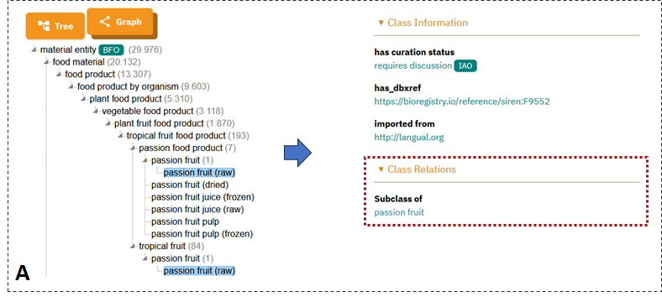
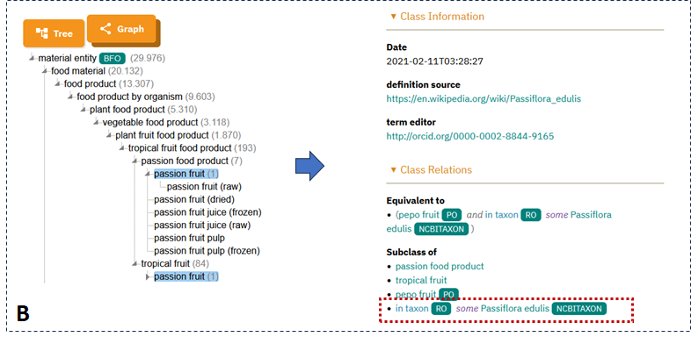
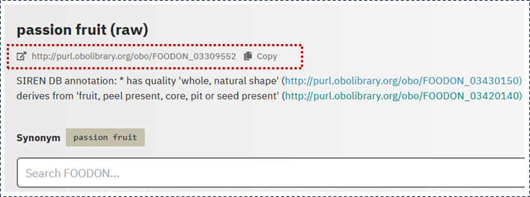

3.3. How to select FoodON Term That Best Suits the Food Product
- Incorporate Preparation Metadata:
When determining the correct Specimen Food Product IRI, consider not only the Specimen Food Product Name but also the Specimen Preparation and Specimen Preparation Method from the CORE metadata to achieve precise classification.
  - Case 1:
    - Specimen Food Product Name: Pumpkin
    - Specimen Preparation: Processed
    - Specimen Preparation Method: Canned
In this instance, selecting "pumpkin" alone may be insufficient. Considering the preparation method suggests a more accurate term: "pumpkin (canned)." The preparation method adequately specifies the food product state.
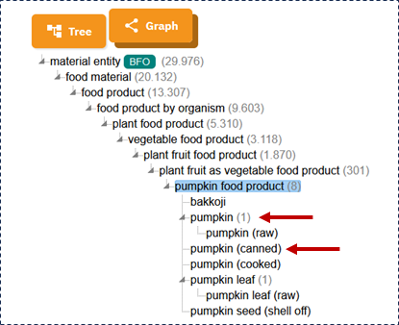

  - Case 2:
    - Specimen Food Product Name: Pumpkin
    - Specimen Preparation: Cooked
    - Specimen Preparation Method: Sauteed
Here, “pumpkin (cooked)” is more precise than simply "pumpkin." Including the cooking method identifies “pumpkin (sauteed)” as the most specific term. If this term doesn’t exist in FoodON, a new term request should be submitted (see Section 3.3).
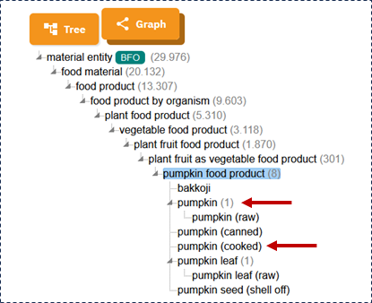
- Consider Breed or Cultivar:
Include the Specimen Breed or Cultivar if it is recognized scientifically or commercially. For example, for “Apple” with preparation as “raw” and cultivar “Fuji,” select “Fuji apple (raw).”
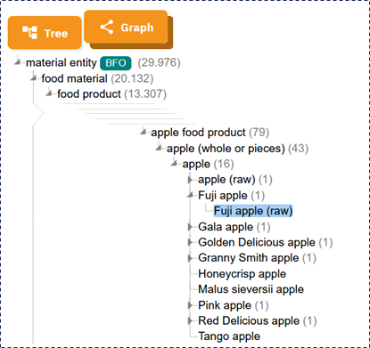
- Use Synonyms:
If no exact FoodON match is found for the Specimen Food Product Name, explore synonyms, alternate local names, or brand names within FoodON or external databases to identify appropriate terms.
- Handle Compound Names Properly:
When the Specimen Food Product Name inherently includes preparation method without parentheses (e.g., “steel cut oats”), ensure the selected FoodON term precisely reflects the specimen’s characteristics to maintain metadata accuracy, regardless of the presence or absence of extra parenthetical details.

Sample Food Product IRI
To assign the 'Sample Food Product' IRI, follow the same procedures as described in the previous section (Section 3.2. and 3.3). However, in this case, use the 'Sample Food Product Name' 'Sample Preparation' and 'Sample Preparation Method' elements to perform the search. In some cases, these elements may be the same for both the specimen and the sample, resulting in the same IRI.

Definition: Curation Status

This step is to define the process for assigning and updating the curation status of food sample metadata, reflecting the current stage of metadata completeness and quality for effective sample tracking and data management. It guides users on whether a sample’s metadata have been properly reviewed, require correction, or are complete for downstream use.
- Required: Assigned when the initial curation process has not yet been performed. This status signals that the sample metadata needs to be curated.

Specimen and Sample Food Product IRI Requests

- Missing: If the FoodON IRIs for specimen and/or sample food products are missing, assign and update status as follows during the term request process
- Required: Specimen food product IRI requested or Sample food product IRI requested

Data Quality and Completeness Checks

When discrepancies, inconsistencies, or errors are found (e.g., missing dry weight or sample weight), add descriptive notes to the status, for example:

- Required: Dry weight missing, Sample weight missing
- Required: If the FoodON IRIs for specimen and/or sample food products are missing, assign and update status as follows during the term request process: Specimen food product IRI requested or Sample food product IRI requested
- Combine : Join these with IRI request statuses as applicable, e.g., Specimen food product IRI requested; sample food product IRI requested; Dry weight missing; sample weight missing
- Required: If the Specimen ABS level is not level 1, append "ABS needed" to the status.
- Combine: Combine with other statuses as required: ABS needed, Specimen food product IRI requested; sample food product IRI requested; Dry weight missing; sample weight missing

Complete: Once all metadata fields are curated, verified, and complete, set the status"Complete"

